Hyperspectral Imaging
1. What is Hyperspectral Imaging?
Hyperspectral Imaging (HSI) is a technique that captures images across hundreds of narrow, continuous spectral bands instead of the usual 3 RGB channels.
Each pixel contains a detailed spectrum, acting like a unique “fingerprint” of materials.
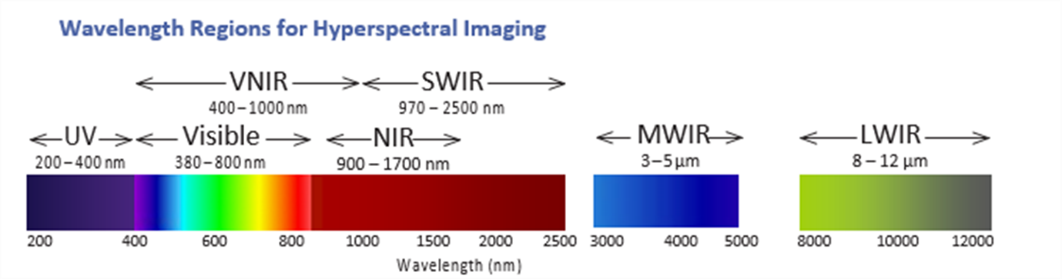
In simple words:
HSI = Imaging + Spectroscopy → For every pixel, we get a full spectrum.
2. Why is HSI Important?
HSI is important because it provides rich spectral information that reveals material composition, chemical properties, and subtle differences that the human eye or RGB cameras cannot detect.
Key benefits
- Identifies materials with high accuracy
- Non-destructive and contactless
- Useful in agriculture, medicine, defence, food quality, geology, etc.
- Works well with AI and machine learning
3. How HSI Works: From Hardware to Software
Hardware: Data Acquisition
The core hardware component is the imaging spectrometer (hyperspectral camera). The most common acquisition method is the Push-broom or Line-scan technique.
- Objective Lens: Focuses the light from the target scene onto a narrow slit.
- Slit: Only allows light from a single one-dimensional line of the scene to pass through.
- Dispersive Element (Grating/Prism): Separates the incoming light into its constituent wavelengths (colors).
- Detector (e.g., CCD/CMOS): The dispersed light strikes the detector. For the single line of the scene, the detector records:
  - One dimension (horizontal) is the spatial line of the scene.
  - The other dimension (vertical) is the spectral information (the hundreds of contiguous wavelengths).
- Scanning Mechanism
Three main types:
- Pushbroom (line-by-line, common in satellites/drones)
- Whiskbroom (point-by-point)
- Snapshot (captures entire cube instantly → fastest)
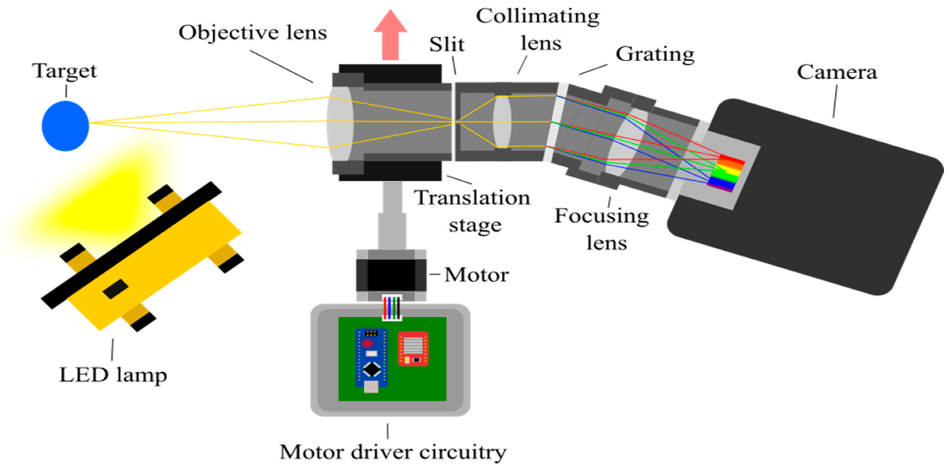
How HSI Works (Hardware → Image)
4. Formation of the Image (Data Cube)
After light is captured and dispersed:
- Sensor collects intensity values at each wavelength
- Spectral bands are stacked to form a 3D cube
HSI cube structure
X = width, Y = height ,λ = wavelength bands
HSI cube = X × Y × λ
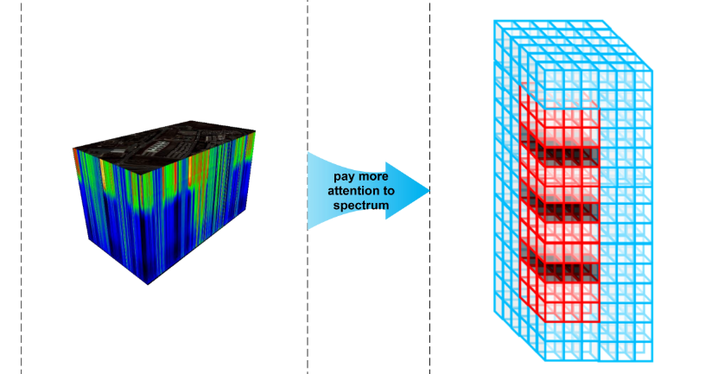
Data Cube
5. Spectral Analysis Algorithms
These analyse spectral signatures.
1 Spectral Matching
- SAM (Spectral Angle Mapper): Treat each spectrum as a vector in λ-dimensional space; compute the angle between the unknown and reference vectors
- SID (Spectral Information Divergence): Treat spectra as probability distributions (after nonnegative normalization). Measure how much the probability distributions diverge
- SAD (Spectral Absorption Depth): Many materials show specific absorption features (valleys) at known wavelengths. SAD quantifies depth/area/position of these absorption features and compares them to reference feature metrics.
2 Spectral Unmixing
Used when one pixel has multiple materials.
Spectral unmixing decomposes each mixed pixel spectrum into a set of pure spectra (endmembers) and their fractional abundances. It answers: which materials are present in a pixel and in what proportion?
(a) Linear Models
- N-FINDR (endmember extraction): find p pixels that form the simplex of maximal volume in spectral space — endmembers assumed to be pure pixels.
- VCA (Vertex Component Analysis): projection-based, exploits orthogonality to iteratively find vertices (endmembers). Faster and popular.
- ICE / PPI
- FCLS (Fully Constrained Least Squares)
(b) Nonlinear Models
- Kernel-based unmixing
- Neural network unmixing

3D – CNN
3D Convolutional Neural Networks (3D-CNN)
1. Introduction
A 3D Convolutional Neural Network (3D-CNN) is an extension of the 2D-CNN architecture that performs convolution along three dimensions: height, width, and depth. In hyperspectral imaging (HSI), the depth dimension typically represents spectral bands. In video processing, depth corresponds to time (frames).
Unlike 2D-CNNs that only learn spatial features, 3D-CNNs learn spatio-spectral or spatio-temporal features, making them ideal for tasks involving multi-dimensional data.

2. Why 3D-CNN?
3D-CNNs capture:
- Spatial texture and structure
- Spectral or temporal variations
- Joint correlations between dimensions
This leads to higher accuracy in domains like:
- Hyperspectral image classification
- Medical imaging (MRI/CT)
- Video action recognition
- 3D object detection

3. Input Structure
2D-CNN Input Format
Channels × Height × Width
3D-CNN Input Format
Channels × Height × Width × Depth

4. Kernel (Filter) Structure
2D-CNN Kernel
(kH × kW)
3D-CNN Kernel
(kH × kW × kD)
- kH = kernel height
- kW = kernel width
- kD = kernel depth (spectral/time dimension)
This is the key difference that enables 3D feature extraction.

5. Convolution Operation (3D)
A 3D convolution slides the kernel along:
- Height
- Width
- Depth
At each location, it computes the sum of element-wise multiplications, producing a 3D feature map.

6. Stride & Padding
2D-CNN:
- Stride: (sH, sW)
- Padding: (pH, pW)
3D-CNN:
- Stride: (sH, sW, sD)
- Padding: (pH, pW, pD)
These works exactly like in 2D, but extended to depth.

7. Architecture of a 3D-CNN Block
A typical 3D-CNN block contains:
- 3D Convolution
- BatchNorm3D
- Activation (ReLU)
- 3D MaxPooling
Example:
Conv3D → BatchNorm3D → ReLU → MaxPool3D → Conv3D → ...
After several blocks, outputs are flattened and fed into:
- Fully Connected (FC) layers
- Softmax classifier

8. Advantages of 3D-CNN
- Learns spatial + spectral/temporal features
- Better accuracy for hyperspectral imaging
- Reduces need for handcrafted feature extraction
- Captures contextual information across depth

9. Disadvantages of 3D-CNN
- Higher computational cost
- Requires more GPU memory
- Larger number of parameters
- Higher risk of overfitting on small datasets

Summary
A 3D-CNN extends classical convolution into the depth dimension, allowing it to learn rich spatio-spectral or spatio-temporal representations. This makes it extremely powerful for applications like hyperspectral imaging, video analysis, and medical data processing, although it requires more computational resources.

